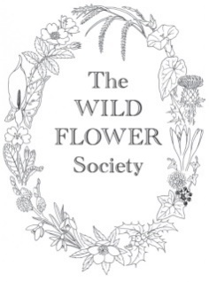
The Wild Flower Society Grant Application Form
Wildlife Trusts
Botanical events for Children and Young People

The Wild Flower Society offers grants of up to £250 per activity, to fund activities for children, families and young people which involve gaining familiarity with wild plants and learning about them. We are looking for events where children will learn to recognise and name flowers and other plants growing in the wild rather than, for example, wild flower gardening.
The plant-based activity could be a whole new event, or it could be one activity within an existing wildlife event, or a botanical session for a regular group or within an ongoing programme of events. The funding could cover staff time, materials or other costs.
This funding may be applied for in addition to botanical training funding for adult volunteers.
Please apply by sending this completed form to wfs.grants.fay@gmail.com before the beginning of March. Applications are considered at the WFS March committee meeting.
If you are applying for more than one grant, please fill in a separate form for each activity.
If you are successful in obtaining a grant, we ask that you acknowledge our support in your publicity and on your website or social media platforms.
A condition of the grant is that, once the training is completed, we require feedback in the form of a brief report of at least 200 words with photos, if possible.
Name of Wildlife Trust
Name of applicant
Email
Telephone

Proposed Event or Activity
Date, duration and location
How will be money be spent? Eg tutor fee, books, equipment
Who will run the activity
Target age range and expected number of young people/children participating.
Type of Activity

